3/14/2025

**Public Transport fare collection and Management system**

A project for the Metro trans limited East Africa

DOCUMENTATION BY: JOYANN WAIRIMU MWANGI

23/05024

BISF

SUPERVISOR: CHARLES MALUNGU

**I, JoyAnn Wairimu Mwangi, hereby declare that the project titled “Public Transport Fare Collection and Management System”**

**is my creation.**

**This work has not been copied, plagiarised, or submitted elsewhere for assessment or publication.**

**I understand that plagiarism or dishonesty may result in disciplinary action.**

**Signature: J.W.M**

**Name: JOYANN WAIRIMU MWANGI**

**Date:14/03/2025**

**This is to declare that this project has been submitted for examination with my approval as the University Supervisor**

**Signature: J.W.M**

**Name: JOYANN WAIRIMU MWANGI**

**Date:14/03/2025**

**ACKNOWLEDGMENTS**

I would like to express my sincere appreciation to everyone who has supported me throughout the development of this project, Public Transport Fare Collection and Management System. This project would not have been possible without the guidance, resources, and encouragement I received from various individuals and institutions.

**Institutional Acknowledgment**

First and foremost, my heartfelt gratitude goes to KCA University for providing an excellent learning environment, including access to invaluable resources such as the library and computer labs, which greatly contributed to the research and development of this project.

**Supervisor & Assessor**

I extend my deepest appreciation to my supervisor, Mr. Charles Malungu, whose invaluable guidance, mentorship, and constructive feedback played a crucial role in shaping this project. His expertise and encouragement have been instrumental in refining my ideas and ensuring the project's success. I also express my gratitude to Mr. Ernest Madara, my assessor, for his critical evaluation and insights, which challenged me to improve the quality of my work.

**Personal Acknowledgments**

I am profoundly grateful to my parents, Mr. Anthony Mwangi and Mrs. Mary Mwangi, for their unwavering support, love, and encouragement throughout my academic journey. Their belief in my abilities has been a great source of motivation.

I would also like to extend my sincere appreciation to my friends Ian Mwangi and Wycliff Muiruri for their constant encouragement, assistance, and moral support during the course of this project. Their companionship and shared experiences have made this journey truly memorable.

**Conclusion**

In conclusion, I am deeply grateful to everyone who contributed in one way or another to the completion of this project. Your support, guidance, and encouragement have been invaluable, and I sincerely appreciate each and every one of you. Thank you for being part of my academic and professional growth.

Sincerely,  
JOYANN MWANGI  
14th March 2025

Table Of Contents

1. Background 4

2. Problem Statement 5

3. Proposed Solution 5

4. Project Objectives 6

4.1. Literature Review 7

5. System Architecture 8

5.1 Client-Side: 8

5.2 Server-Side: 8

5.3 Communication: 8

6. Functional Requirements 8

7. Non-Functional Requirements 9

8. Database Design 9

8.1 Entity-Relationship Diagram: 9

9. API Documentation 10

10. Implementation 11

11. Challenges & Solutions 11

12. Testing & Deployment 11

13. Conclusion 11

14. 12

14.1 Data Flow Diagram 12

14.2 User Interface Diagram 13

# 1. Background

Metro trans Investments Limited was founded in 2020 from a humble beginning. It has grown to be a regional logistics and supply chain leader that moves business and industry through innovations inspiration and foresight. As an employer of more than 200+ people locally, Metro trans delivers excellence in end-to-end logistics and supply chain management daily. Their consistent growth track record is a testament not only to their ongoing expansion but a focus on investing in their people and customers while delivering distinct balance between sustainable business service delivery and employees’ growth.

Metro trans Investments Limited operates a fleet that includes prime movers, 30T trailers, 15T lorries,10T lorries and tipper trailers. We specialize in cargo transport, short haul service, long haul road freight, corporate transport, staffs transport, Student transport; for notable clients such as Maersk, Siginon, DHL, Rai Sugar, Lori, Sukari Industries, AGL, Delmonte Kenya Limited, Twiga Foods, Brookside Dairies, Kenya Tea Packers Limited (KETEPA), Kenya Tea Development Authority (KTDA), Associated Battery Manufacturers (ABM), Greenfield Tea factory, Mombasa Cement, Menengai Oil, Pwani Oil, Frigoken Spiceken EPZ Limited, and Precision Plastics Limited.

Additionally, Metro trans East Africa Limited manages over 200 PSV buses that provide logistical support to the more than 1,000,000 city workers and dwellers.

***Our vision***

To provide reliable, punctual, comfortable and cost-effective services to meet our clients transport needs in a personalized exemplary manner.

***Our mission***

To be the leading transport service provider in East African region, offering affordable, safe, efficient transport services to our clients.

***Our values***

Company values are an important component in the overall strategic framework and operations of the organization. Metro trans Investments Ltd was established on the following values:

* Reliability – the provision of dependable service that our customers can rely on.
* Quality – a commitment to quality service and safety at all times.
* Integrity – compliance with company and positive societal norms and standards.
* Respect – a courteous disposition amongst staff, and towards clients.
* Teamwork – an environment which encourages pursuance of a common purpose to the delight of our customers.

# 2. Problem Statement

Metro trans East Africa is currently facing substantial financial and operational challenges due to inefficiencies in its fare collection system. A significant portion of revenue is lost as some touts engage in unethical practices, such as underreporting collected fares or pocketing cash payments. The lack of a transparent and tamper-proof monitoring mechanism enables these fraudulent activities to persist, reducing the company’s profitability.

Additionally, the rise in digital transactions has introduced a new loophole in the form of fare reversals. Some passengers exploit weaknesses in the digital payment system by initiating chargebacks after completing their journeys. These reversals often go undetected or are difficult to contest, further contributing to revenue losses.

The combined effect of internal theft and fraudulent transactions results in a significant decline in revenue collection, limiting the company’s ability to expand and enhance service quality. Without a secure, automated, and real-time fare collection system, these financial discrepancies will continue to affect Metro trans East Africa’s sustainability. Addressing these challenges requires a solution that ensures accurate fare reporting, prevents unauthorized fund reversals, and strengthens overall financial transparency

# 3. Proposed Solution

To effectively mitigate revenue losses and enhance operational efficiency, we propose the implementation of an **Integrated Digital Fare Collection and Monitoring System**. By leveraging technology-driven solutions, this system will significantly enhance financial transparency, curb revenue leakages, and improve customer trust in Metro trans East Africa’s services. The proposed solution will not only safeguard the company’s financial health but also pave the way for long-term operational sustainability and expansion.

Moreover, this solution will eliminate cash-based transactions, introduce real-time tracking, and secure digital payments to prevent unauthorized reversals. The key components of the proposed system include:

1. **Cashless Fare Collection Mechanism**

Implementing a robust prepaid fare system where customers use digital wallets, mobile payments, or NFC-enabled smart cards to pay for rides. This ensures accurate and trackable transactions, reducing the risk of theft by touts.

1. **Tamper-Proof Payment Processing**

Introducing a secure payment gateway that immediately settles transactions to prevent chargebacks. This system will integrate multi-factor authentication and confirmation protocols to ensure only valid transactions are processed.

1. **Automated Passenger Validation**

Deploying QR code or NFC-based validation devices at bus entry points to confirm payment before boarding. This eliminates disputes over fare payments and enhances transaction accountability.

1. **Real-Time Transaction Monitoring Dashboard**

Establishing a centralized monitoring system that provides real-time visibility into transactions across all buses. This will allow management to track revenue, detect anomalies, and take immediate corrective action.

1. ***Tout Accountability and Performance Tracking***

Introducing an employee accountability system that links collected fares to individual touts, ensuring transparency in fare handling and reducing misappropriation.

1. ***Enhanced Security and Fraud Prevention Measures***

Implementing a fraud detection system to identify suspicious payment patterns and potential reversals. This includes automated alerts and audits to flag anomalies for further investigation.

# 4. Project Objectives

The main aim of the Project is to mitigate revenue losses and enhance operational efficiency within the logistic industry specifically in Metro trans East Africa. The project objectives are as follows:

1. ***Enhance Financial Transparency and Accountability***

This will be achieved through the implementation of a secure and trackable digital fare collection system that eliminates cash handling and ensures accurate revenue reporting.

1. ***Minimize Revenue Leakages and Fraud***

This will be achieved through the deployment of advanced security features to prevent unauthorized fare reversals, tout theft, and other financial malpractices.

1. ***Improve Operational Efficiency***

This will be achieved through the automation of the fare collection and monitoring process to reduce manual errors, administrative workload, and delays in revenue reconciliation.

1. ***Strengthen Passenger Convenience and Trust***

This will be achieved through provision of a seamless and efficient payment experience by introducing multiple secure cashless payment options, enhancing customer satisfaction and loyalty.

1. ***Increase Management Oversight and Control***

This will be achieved by establishing real-time data analytics and monitoring capabilities to detect anomalies, track fare collection trends, and enable swift corrective action.

1. ***Facilitate Business Growth and Sustainability***

This project seeks to facilitate financial stability and improved revenue collection, enabling Metro trans East Africa to expand its fleet, enhance service delivery, and maintain long-term sustainability in the transport sector.

### 4.1. Literature Review

Fare collection systems are not a new phenomenon in the transport industry and are continually being introduced and improved with the rise of new tactics in fraud. Case studies of successfully implemented systems in cities such as Kigali show that digital fare systems improve revenue collection efficiency. Theoretically, several academic studies highlight the significance of digital fare collection systems in reducing financial losses and improving efficiency in public transportation. According to World Bank research, digital fare collection mechanisms have been instrumental in curbing revenue pilferage and enhancing accountability in urban transit systems (World Bank, 2020).

A study by Kumar and Gupta (2019), emphasizes that cashless transactions in public transport significantly reduce fraudulent activities and enhances passenger convenience. The integration of NFC-enabled smart cards and mobile payments has been shown to improve fare accuracy and transparency, minimizing financial leakages. Further, Komba and Kayuni (2021) explore the impact of real-time monitoring in public transport systems, concluding that digital dashboards allow management to track financial flows and detect discrepancies, thus improving financial oversight and control. Similarly, a report by the International Association of Public Transport (UITP, 2018) suggests that automated fare collection systems lead to a 20-30% increase in revenue by eliminating loopholes associated with manual fare handling.

In addressing fraud prevention, Li et al. (2022) proposes AI-driven fraud detection techniques to identify suspicious transactions and unauthorized reversals. Their study highlights the effectiveness of machine learning algorithms in identifying patterns indicative of financial misconduct. The need for enhanced security in digital transactions is also well documented. According to a study by Smith and Brown (2020), multi-factor authentication and end-to-end encryption significantly reduce instances of chargebacks and unauthorized fare reversals in digital payment systems.

These studies collectively demonstrate that integrating digital fare collection, real-time monitoring, and fraud detection mechanisms can significantly improve financial transparency, prevent revenue losses, and enhance operational efficiency. By adopting such solutions, Metro trans East Africa can address its financial challenges and create a more sustainable public transport model.

## 4.2 Risk management

Here’s a table showing potential risks and their mitigation measures for Public transport fare collection and management system

| Risk | Description | Mitigation Measures |
| --- | --- | --- |
| Laptop Failure | The development laptop may crash or become unusable. | Regularly back up project files to an external drive and cloud storage. Use a secondary device if possible. |
| Data Loss | Accidental deletion or corruption of important files. | Implement version control (Git), use cloud backups, and maintain redundant copies of essential data. |
| Security Vulnerabilities | Potential flaws in encryption implementation. | Conduct thorough security testing, use well-established libraries like OpenSSL, and perform code audits. |
| Scope Creep | Additional features may be requested beyond initial scope. | Clearly define project scope and timeline. Use Agile methodologies to track progress and requirements. |
| Time Constraints | Insufficient time for development and testing. | Follow a structured project plan with milestones. Prioritize critical features first. |
| Software Bugs | Unexpected errors in encryption, decryption, or UI. | Perform unit testing, debugging, and continuous integration testing. |
| User Usability Issues | The system may be difficult for non-technical users. | Conduct usability testing and refine the UI based on feedback. |
| Key Management Challenges | Users may lose or mishandle encryption keys. | Implement secure key storage mechanisms and provide recovery options. |
| Regulatory Compliance Issues | The system may not meet legal security standards. | Ensure compliance with NIST and GDPR guidelines for data encryption. |
| Integration Issues | Compatibility problems with different operating systems. | Test the application on multiple platforms (Windows, Linux) before deployment. |

## 4.3. Budget and Resources

|  |  |
| --- | --- |
| **Item** | **Estimated Cost (KSH)** |
| System Development & Integration | 150,000 |
| Hardware (Card readers, QR scanners) | 100,000 |
| Pilot Testing & Training | 50,000 |
| Marketing & Awareness Campaign | 40,000 |
| Monitoring & Maintenance (1st year) | 70,000 |
| **Total Estimated Cost** | **410,000** |

## 4.4 Project Schedule

|  |  |  |  |  |  |  |  |  |  |  |  |  |  |  |  |  |  |  |  |  |  |  |  |  |  |
| --- | --- | --- | --- | --- | --- | --- | --- | --- | --- | --- | --- | --- | --- | --- | --- | --- | --- | --- | --- | --- | --- | --- | --- | --- | --- |
| |  |  |  |  | | --- | --- | --- | --- | | **Task number** | **Task** | **Start Date** | **Completion**  **Date** | | 1 | Research and planning | 18/01/2025 | 01/02/2025 | | 2 | System Development | 07/02/2025 | 17/03/2025 | | 3 | Pilot Testing | 20/03/2025 | 30/03/2025 | | 4 | Staff and customer training | 01/04/2025 | 14/04/2025 | | 5 | Full scale implementation | 16/04/2025 | 31/04/2025 | |  |
|  |  |
|  |  |

# 5. System Architecture

## 5.1 Client-Side:

* + Users scan a QR code or tap an NFC card to initiate payment.
  + The frontend sends the transaction request to the backend.

## 5.2 Server-Side:

* + Flask API processes transactions.
  + MySQL stores payment records.

## 5.3 Communication:

* + RESTful API endpoints facilitate data exchange.

# 6. Functional Requirements

* **User Registration**: Passengers can sign up and link their payment methods.
* **Balance Management**: Users can load funds into their accounts.
* **Transaction Processing**: Secure payment validation and processing.
* **Fare Calculation**: Automatic fare calculation based on distance or zones.
* **Admin Dashboard**: Transport operators can monitor transactions and manage users.

# 7. Non-Functional Requirements

* **Security**: Encrypted transactions and secure authentication.
* **Scalability**: Supports multiple transport systems.
* **Availability**: Ensures 99.9% uptime for transactions.

# 8. Database Design

* **Tables Overview:**

| **Table Name** | **Description** |
| --- | --- |
| Users | Stores user details (ID, name, balance) |
| Transactions | Records all payment transactions (ID, user, amount, timestamp) |
| Fares | Stores fare amounts based on routes |

8.1 Entity-Relationship Diagram:

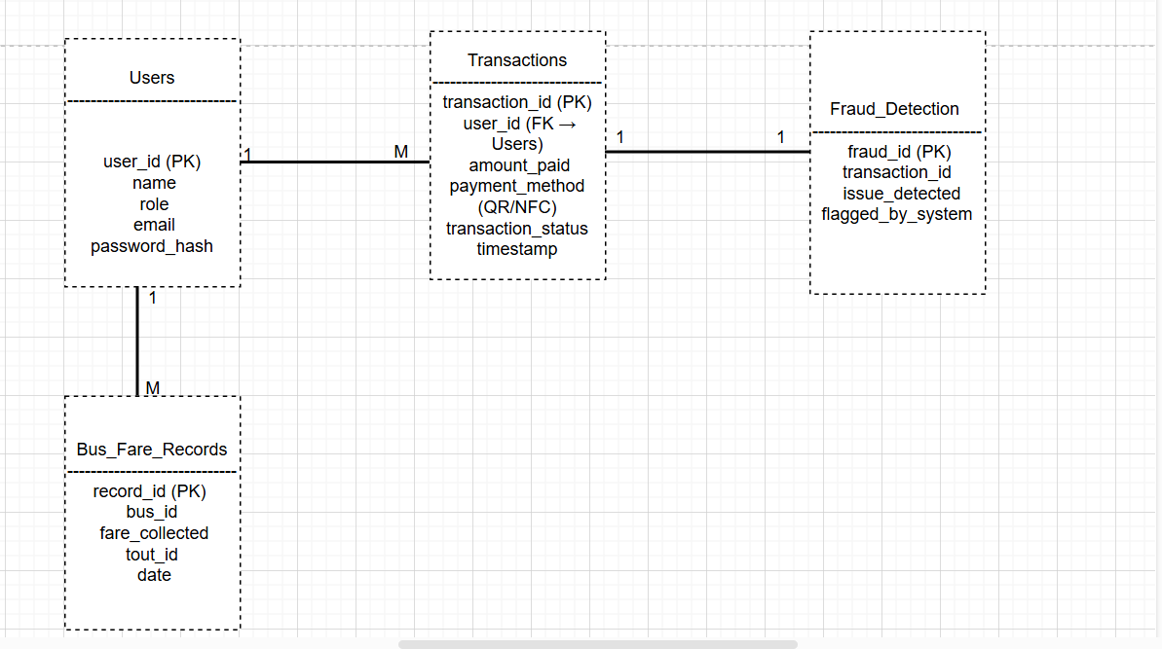

# 9. API Documentation

* **Base URL:** http://127.0.0.1:5001/
* **Endpoints:**
  + POST /calculate_fare
    - **Description:** Calculate fare based on pickup and drop-off locations.
    - **Request Body:**
    - {
    - "fromLocation": "locationA",
    - "toLocation": "locationB"
    - }
    - **Response:**
    - {
    - "fare": 50
    - }

# 10. Implementation

* **QR Code Processing**:
  + Generate and scan QR codes for fare payments.
* **NFC Integration**:
  + Read NFC cards using mobile devices.
* **API Development**:
  + Endpoints for fare calculation, user balance updates, and transaction logging.

# **11.** Challenges & Solutions

* **Database Connection Errors**: Resolved by ensuring MySQL service is running and credentials are correct.
* **REST API Connectivity Issues**: Fixed by verifying Flask server availability and using correct ports.
* **Security Concerns**: Implemented encryption for sensitive data.

# **12.** Testing & Deployment

* **Unit Testing**: Ensured all modules work individually.
* **Integration Testing**: Verified seamless interaction between frontend, backend, and database.
* **Deployment**: Hosted on a local server, with potential for cloud deployment.

13. Conclusion

* **Future Enhancements**: Expansion to include mobile app integration and support for additional payment gateways.
* **Impact**: Reduces fraud, improves efficiency, and enhances commuter convenience.

14.Screenshots & Diagrams

## 14.1 Data Flow Diagram

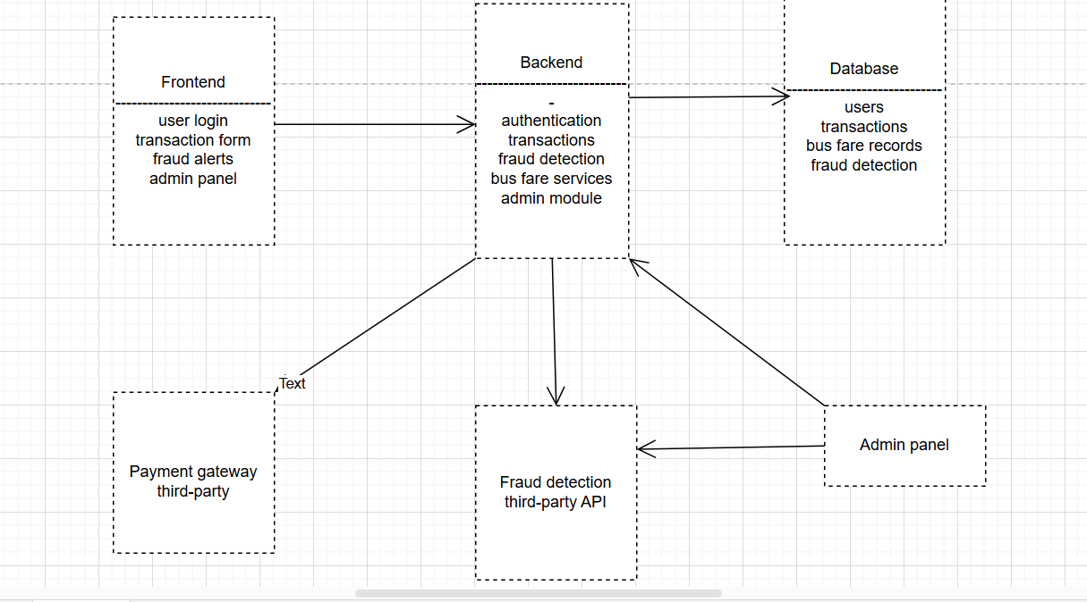

## 14.2 User Interface Diagram

